**ELECTIVE 3: FULLSTACK WEB DEVELOPMENT**

**PRELIMINARY EXAMINATION**

**1st Semester, Academic Year 2019-2020**

Please follow the directions for each section. Note that in each section you will have some amount of choice in the questions you’ll be answering. The exam is based on a 100-point scale. Partial credit will be given for answers that are done partially well.

**Programming** (50 points ).

1. Create a basic website (without JavaScript) that has the following layout below with the ff. Instructions
   1. Should be posted in Github with the format E3PE_LASTNAME_FIRSTNAME for the project name.
   2. Follow layout below:

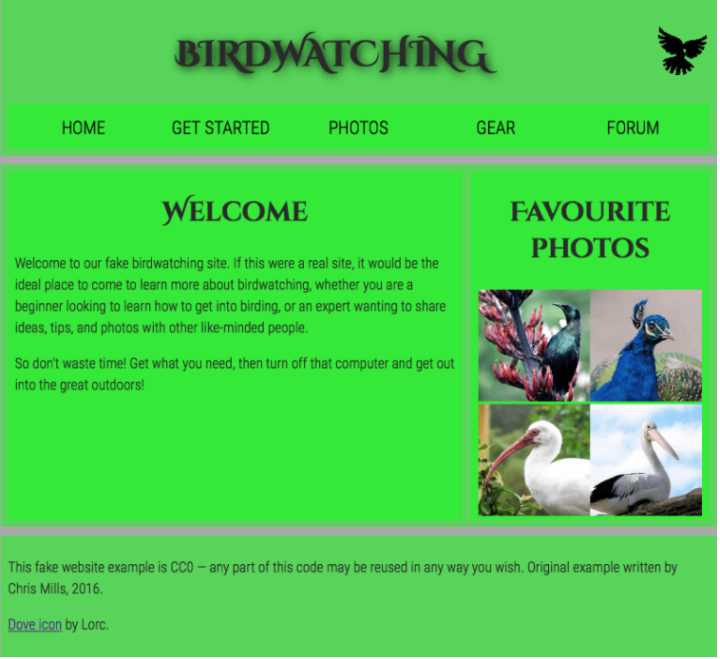

* 1. Logos and pictures can be changed.
  2. Fonts can be altered.

**Essay** (25 points):

1. How would you say that front-end development has evolved over the years? State some key difference from then (like 10 years ago) to now.

I guess it improves in terms of productivity and ease. It is now easier than before because it doesn’t require so much effort and time to settle your workspace. In just one click, all the extension and other things you need are already there. No need to manually set the environment. You can also notice and know if you have an error and easier to debug because of how predictive it is.

1. Provide a code snippet that shows CSS precedence between element selectors, class selectors and inline styling.

ghibli.html

<!doctype html>

<html lang="en">

<head>

<!-- Required meta tags -->

<meta charset="utf-8">

<meta name="viewport" content="width=device-width, initial-scale=1">

<!-- Bootstrap CSS -->

<!-- <link href="https://cdn.jsdelivr.net/npm/bootstrap@5.0.0-beta3/dist/css/bootstrap.min.css"

rel="stylesheet"

integrity="sha384-eOJMYsd53ii+scO/bJGFsiCZc+5NDVN2yr8+0RDqr0Ql0h+rP48ckxlpbzKgwra6"

crossorigin="anonymous"> -->

<link href='ghibliback.css' rel='stylesheet'/>

<title> Welcome to The Studio Ghibli </title>

</head>

<body>

<header>

<ul>

<h2 id="Home"> The Studio Ghibli <br>スタジオジブリ </h2>

</ul>

<nav>

<ul>

<li><a href="#">Home</a></li>

<li><a href="#">About</a></li>

<li><a href="#">Album</a></li>

<li><a href="#">Ghibli Arts</a></li>

<li><a href="#">Forum</a></li>

</ul>

</nav>

</header>

<table>

<tr>

<td>

<h1> Welcome to <br>The<br>Studio Ghibli! </h1>

</td>

<th>

<img src="spiritedaway.jpg" width="250" height="400">

</th>

<th>

<img src="ponyo.jpg" width="250" height="400">

</th>

</tr>

</table>

<div class="footer">

<h3> This is For Educational purposes only, No Copyright Infrindgement Intended. </h3>

</div>

</body>

</html>

ghibliback.css

body, html {

height: 125vh;

background-image: url('GhibliHome.jpg');

background-repeat: no-repeat;

background-attachment: fixed;

background-size: 100%,100%;

}

header {

background-color: White;

position: fixed;

top: 0;

left: 0;

right: 0;

height: 80px;

display: flex;

align-items: center;

box-shadow: 0 0 25px 0 black;

}

header * {

display: inline;

}

header li {

margin: 80px;

}

header li a {

color: black;

text-decoration: none;

}

#Home {

color: #e8e4c9;

text-shadow:

-1px -1px 0 #000,

1px -1px 0 #000,

-1px 1px 0 #000,

1px 1px 0 #000;

font-family:'Open Sans';

}

h1 {

padding-left: 40px;

font-size:70px;

padding-top: 150px;

font-family: Verdana;

color: #FCFAED;

text-shadow:

-2px -2px 0 #000,

2px -2px 0 #000,

-2px 2px 0 #000,

2px 2px 0 #000;

}

h2 {

font-family: Open Sans;

color: #FCFAED;

text-shadow:

-1px -1px 0 #000,

1px -1px 0 #000,

-1px 1px 0 #000,

1px 1px 0 #000;

}

}

p {

font-family: Verdana;

color: White;

font-size: 20px;

}

th {

box-shadow: 0 0 25px 0 black;

border-spacing: 50px;

}

table, td {

border-spacing: 50px;

}

.footer {

position: fixed;

font-size: 10px;

background-color: White;

text-align: center;

box-shadow: 0 0 25px 0 black;

left: 0;

bottom: 0;

width: 100%;

height: 5%;

|  |  |  |
| --- | --- | --- |
| Prepared By:  NINO FRANCISCO ALAMO  Professor /Instructor | Reviewed By:  REGIE ELLANA  CCS Dean | Approved By:  DR. LEAH DIGO  VP for Academic Affairs |

|  |
| --- |
| **LOA-OAA-TOS-028** |
| **10-02-2020 | REV. 00** |

|  |  |
| --- | --- |
| **CODE** | **ELEC323** |
| **TITLE** | **ELECTIVE 3: FULLSTACK DEVELOPMENT** |
| **EXAM** | **PRELIMINARY EXAMINATION** |
| **TERM/AY** | **2ND SEMESTER, ACADEMIC YEAR 2019-2020** |

|  |  |  |  |  |  |  |  |  |
| --- | --- | --- | --- | --- | --- | --- | --- | --- |
| **Topic #** | **Objectives** | **Remember** | **Understand** | **Apply** | **Analyze** | **Evaluate** | **Create** | **Total # of Items/points** |
| 1 | * To apply the concepts of MVC   + - * + Creating Views         + Persisting to Database | 2 | 2 | 2 | 1 | 1 | 2 | **10** |
| **Total # of items/Points** | | 2 | 2 | 2 | 1 | 1 | **2** | **10** |

|  |  |  |
| --- | --- | --- |
| Prepared By:  NINO FRANCISCO ALAMO  Professor /Instructor | Reviewed By:  REGIE ELLANA  CCS Dean | Approved By:  DR. LEAH DIGO  VP for Academic Affairs |